Машов, Сп. Римска военна диплома от с. Сохаче, Врачански оклъг.
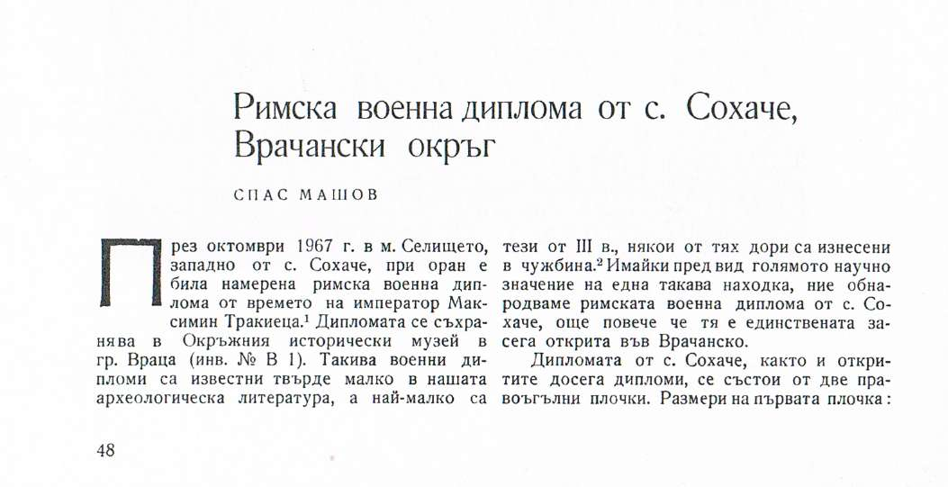

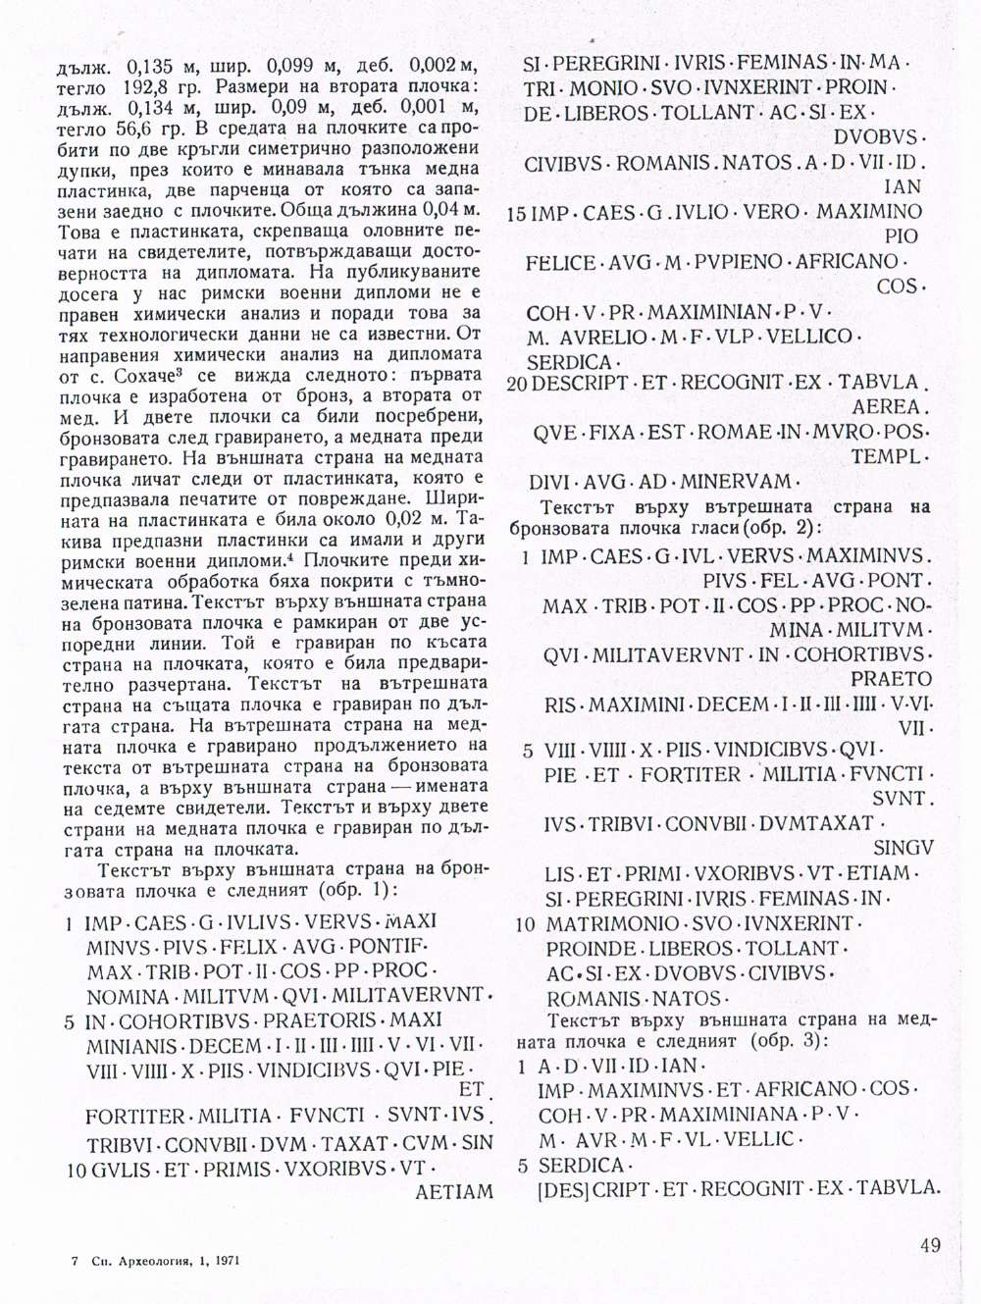

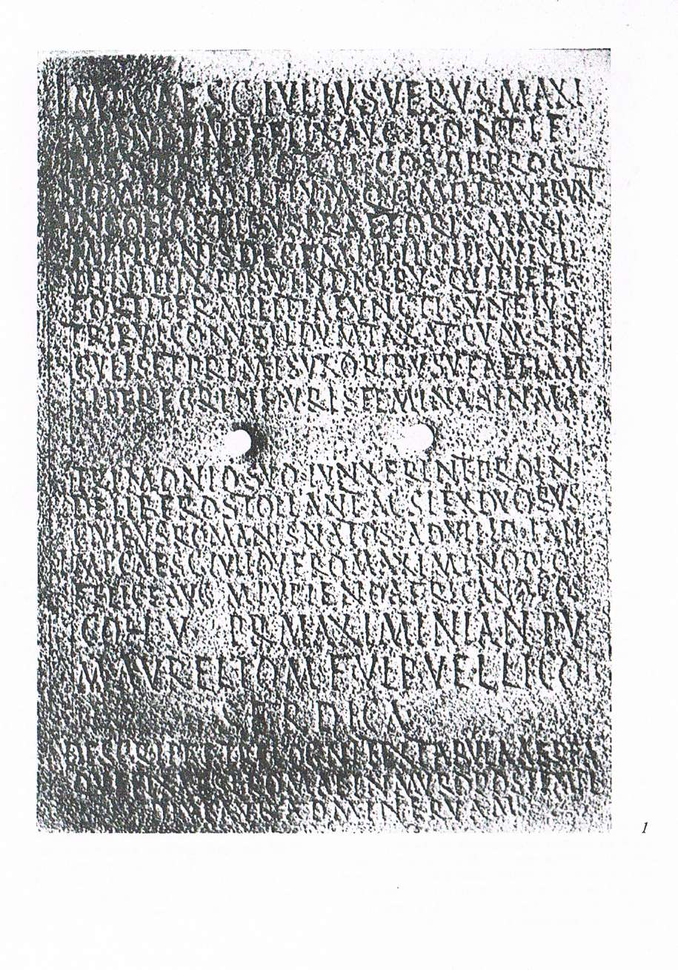

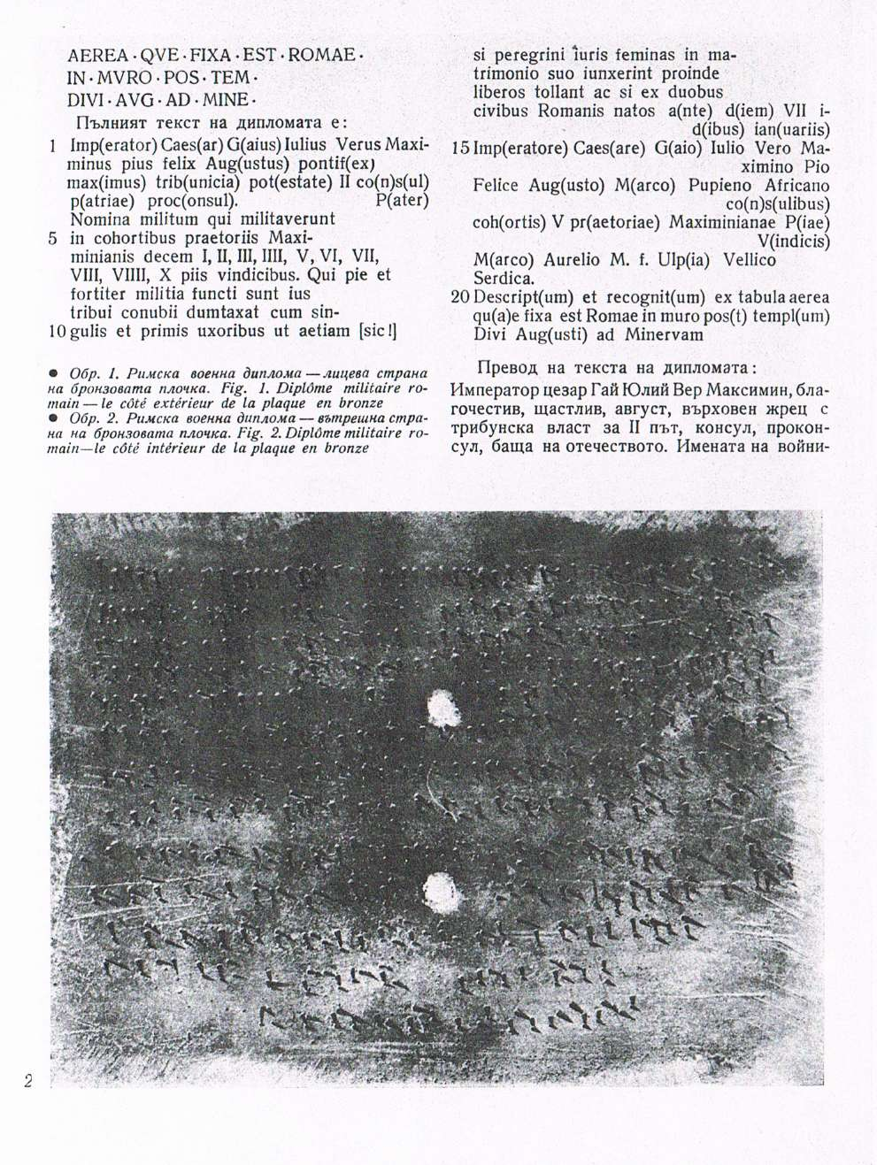

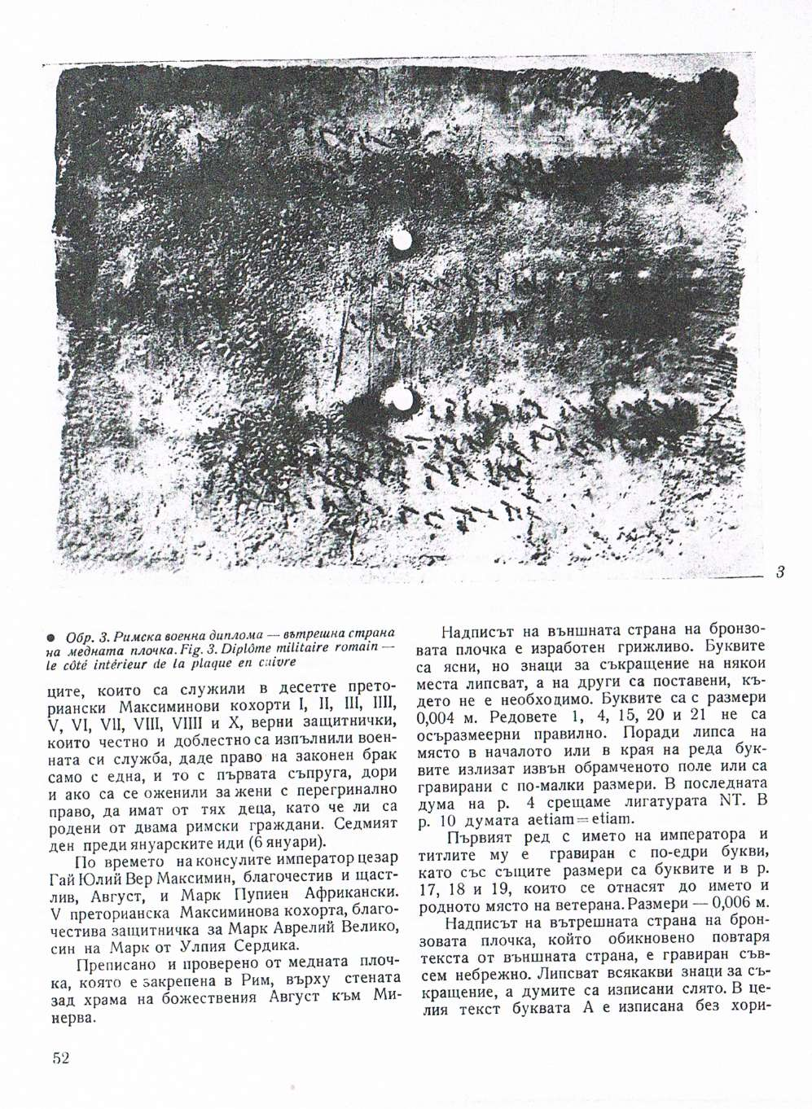

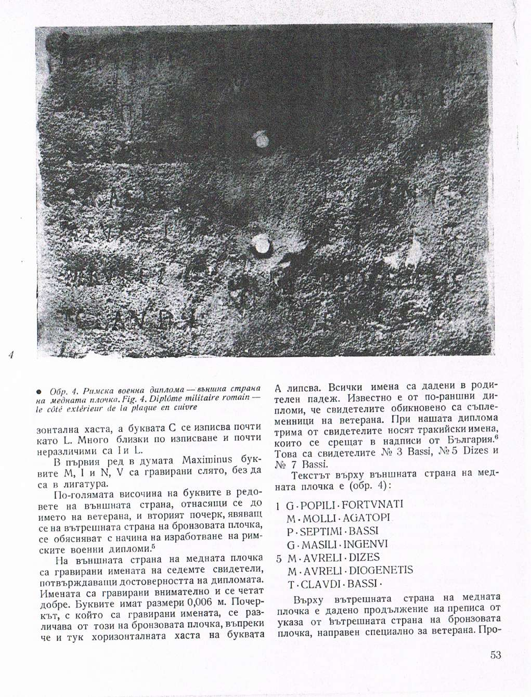

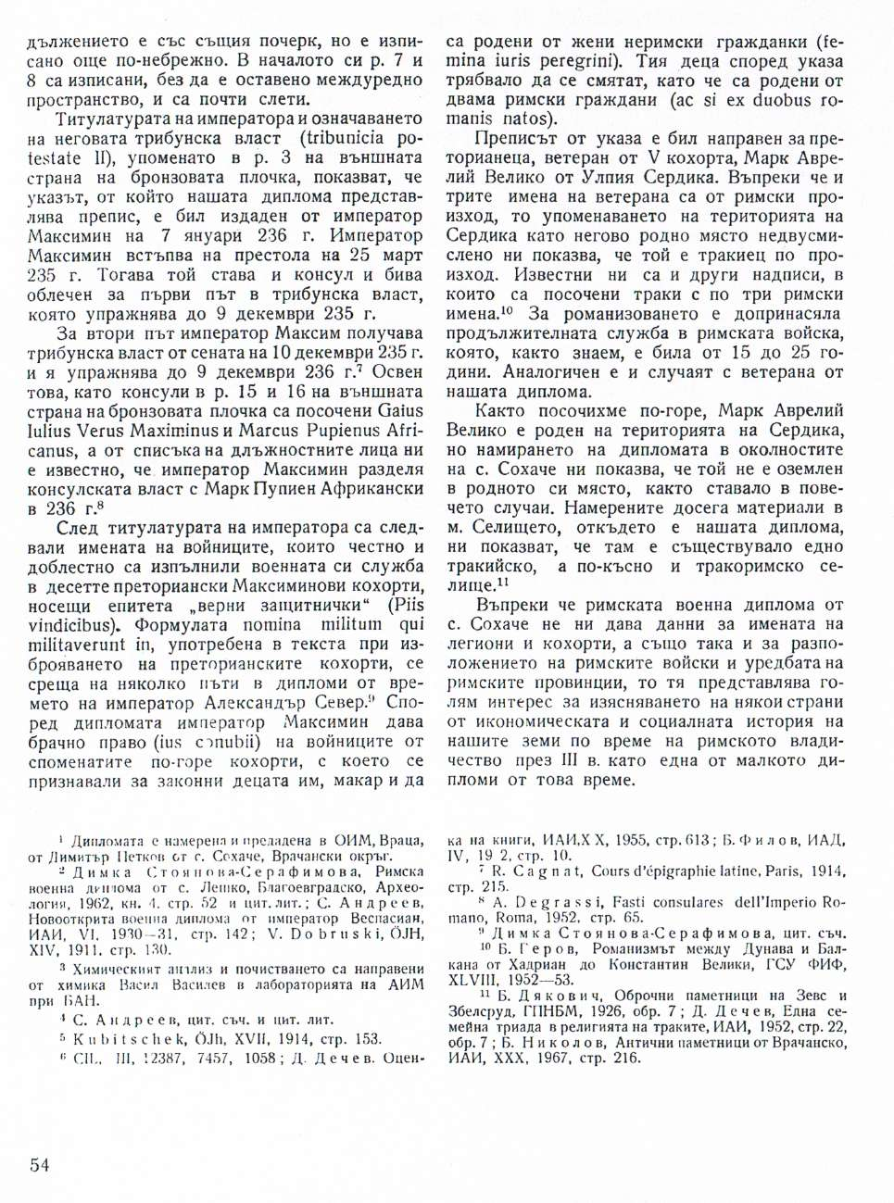

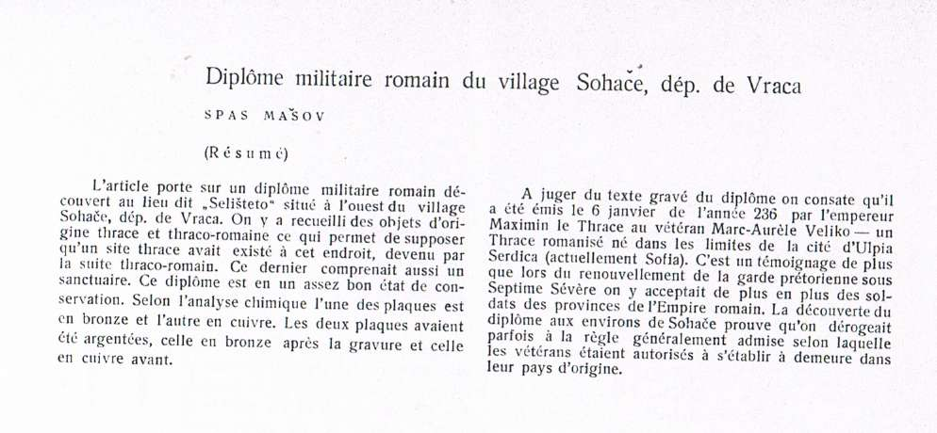

Машов, Сп. Римска военна диплома от с. Сохаче, Врачански оклъг. А., 1971, 1, с. 48-55.

INCLUDEPICTURE "http://t0.gstatic.com/images?q=tbn:ANd9GcTDT1jpfS6n_Y4NmsXFnf0dV2uAk854tEHeOSaIXPxUCt7qxHu5xaSaZA" \* MERGEFORMATINET INCLUDEPICTURE "http://t0.gstatic.com/images?q=tbn:ANd9GcTDT1jpfS6n_Y4NmsXFnf0dV2uAk854tEHeOSaIXPxUCt7qxHu5xaSaZA" \* MERGEFORMATINET INCLUDEPICTURE "http://t0.gstatic.com/images?q=tbn:ANd9GcTDT1jpfS6n_Y4NmsXFnf0dV2uAk854tEHeOSaIXPxUCt7qxHu5xaSaZA" \* MERGEFORMATINET INCLUDEPICTURE "http://t0.gstatic.com/images?q=tbn:ANd9GcTDT1jpfS6n_Y4NmsXFnf0dV2uAk854tEHeOSaIXPxUCt7qxHu5xaSaZA" \* MERGEFORMATINET INCLUDEPICTURE "http://t0.gstatic.com/images?q=tbn:ANd9GcTDT1jpfS6n_Y4NmsXFnf0dV2uAk854tEHeOSaIXPxUCt7qxHu5xaSaZA" \* MERGEFORMATINET INCLUDEPICTURE "http://t0.gstatic.com/images?q=tbn:ANd9GcTDT1jpfS6n_Y4NmsXFnf0dV2uAk854tEHeOSaIXPxUCt7qxHu5xaSaZA" \* MERGEFORMATINET INCLUDEPICTURE "http://t0.gstatic.com/images?q=tbn:ANd9GcTDT1jpfS6n_Y4NmsXFnf0dV2uAk854tEHeOSaIXPxUCt7qxHu5xaSaZA" \* MERGEFORMATINET INCLUDEPICTURE "http://t0.gstatic.com/images?q=tbn:ANd9GcTDT1jpfS6n_Y4NmsXFnf0dV2uAk854tEHeOSaIXPxUCt7qxHu5xaSaZA" \* MERGEFORMATINET INCLUDEPICTURE "http://t0.gstatic.com/images?q=tbn:ANd9GcTDT1jpfS6n_Y4NmsXFnf0dV2uAk854tEHeOSaIXPxUCt7qxHu5xaSaZA" \* MERGEFORMATINET INCLUDEPICTURE "http://t0.gstatic.com/images?q=tbn:ANd9GcTDT1jpfS6n_Y4NmsXFnf0dV2uAk854tEHeOSaIXPxUCt7qxHu5xaSaZA" \* MERGEFORMATINET INCLUDEPICTURE "http://t0.gstatic.com/images?q=tbn:ANd9GcTDT1jpfS6n_Y4NmsXFnf0dV2uAk854tEHeOSaIXPxUCt7qxHu5xaSaZA" \* MERGEFORMATINET INCLUDEPICTURE "http://t0.gstatic.com/images?q=tbn:ANd9GcTDT1jpfS6n_Y4NmsXFnf0dV2uAk854tEHeOSaIXPxUCt7qxHu5xaSaZA" \* MERGEFORMATINET INCLUDEPICTURE "http://t0.gstatic.com/images?q=tbn:ANd9GcTDT1jpfS6n_Y4NmsXFnf0dV2uAk854tEHeOSaIXPxUCt7qxHu5xaSaZA" \* MERGEFORMATINET INCLUDEPICTURE "http://t0.gstatic.com/images?q=tbn:ANd9GcTDT1jpfS6n_Y4NmsXFnf0dV2uAk854tEHeOSaIXPxUCt7qxHu5xaSaZA" \* MERGEFORMATINET INCLUDEPICTURE "http://t0.gstatic.com/images?q=tbn:ANd9GcTDT1jpfS6n_Y4NmsXFnf0dV2uAk854tEHeOSaIXPxUCt7qxHu5xaSaZA" \* MERGEFORMATINET INCLUDEPICTURE "http://t0.gstatic.com/images?q=tbn:ANd9GcTDT1jpfS6n_Y4NmsXFnf0dV2uAk854tEHeOSaIXPxUCt7qxHu5xaSaZA" \* MERGEFORMATINET INCLUDEPICTURE "http://t0.gstatic.com/images?q=tbn:ANd9GcTDT1jpfS6n_Y4NmsXFnf0dV2uAk854tEHeOSaIXPxUCt7qxHu5xaSaZA" \* MERGEFORMATINET INCLUDEPICTURE "http://t0.gstatic.com/images?q=tbn:ANd9GcTDT1jpfS6n_Y4NmsXFnf0dV2uAk854tEHeOSaIXPxUCt7qxHu5xaSaZA" \* MERGEFORMATINET INCLUDEPICTURE "http://t0.gstatic.com/images?q=tbn:ANd9GcTDT1jpfS6n_Y4NmsXFnf0dV2uAk854tEHeOSaIXPxUCt7qxHu5xaSaZA" \* MERGEFORMATINET INCLUDEPICTURE "http://t0.gstatic.com/images?q=tbn:ANd9GcTDT1jpfS6n_Y4NmsXFnf0dV2uAk854tEHeOSaIXPxUCt7qxHu5xaSaZA" \* MERGEFORMATINET INCLUDEPICTURE "http://t0.gstatic.com/images?q=tbn:ANd9GcTDT1jpfS6n_Y4NmsXFnf0dV2uAk854tEHeOSaIXPxUCt7qxHu5xaSaZA" \* MERGEFORMATINET INCLUDEPICTURE "http://t0.gstatic.com/images?q=tbn:ANd9GcTDT1jpfS6n_Y4NmsXFnf0dV2uAk854tEHeOSaIXPxUCt7qxHu5xaSaZA" \* MERGEFORMATINET INCLUDEPICTURE "http://t0.gstatic.com/images?q=tbn:ANd9GcTDT1jpfS6n_Y4NmsXFnf0dV2uAk854tEHeOSaIXPxUCt7qxHu5xaSaZA" \* MERGEFORMATINET INCLUDEPICTURE "http://t0.gstatic.com/images?q=tbn:ANd9GcTDT1jpfS6n_Y4NmsXFnf0dV2uAk854tEHeOSaIXPxUCt7qxHu5xaSaZA" \* MERGEFORMATINET INCLUDEPICTURE "http://t0.gstatic.com/images?q=tbn:ANd9GcTDT1jpfS6n_Y4NmsXFnf0dV2uAk854tEHeOSaIXPxUCt7qxHu5xaSaZA" \* MERGEFORMATINET INCLUDEPICTURE "http://t0.gstatic.com/images?q=tbn:ANd9GcTDT1jpfS6n_Y4NmsXFnf0dV2uAk854tEHeOSaIXPxUCt7qxHu5xaSaZA" \* MERGEFORMATINET INCLUDEPICTURE "http://t0.gstatic.com/images?q=tbn:ANd9GcTDT1jpfS6n_Y4NmsXFnf0dV2uAk854tEHeOSaIXPxUCt7qxHu5xaSaZA" \* MERGEFORMATINET INCLUDEPICTURE "http://t0.gstatic.com/images?q=tbn:ANd9GcTDT1jpfS6n_Y4NmsXFnf0dV2uAk854tEHeOSaIXPxUCt7qxHu5xaSaZA" \* MERGEFORMATINET INCLUDEPICTURE "http://t0.gstatic.com/images?q=tbn:ANd9GcTDT1jpfS6n_Y4NmsXFnf0dV2uAk854tEHeOSaIXPxUCt7qxHu5xaSaZA" \* MERGEFORMATINET INCLUDEPICTURE "http://t0.gstatic.com/images?q=tbn:ANd9GcTDT1jpfS6n_Y4NmsXFnf0dV2uAk854tEHeOSaIXPxUCt7qxHu5xaSaZA" \* MERGEFORMATINET INCLUDEPICTURE "http://t0.gstatic.com/images?q=tbn:ANd9GcTDT1jpfS6n_Y4NmsXFnf0dV2uAk854tEHeOSaIXPxUCt7qxHu5xaSaZA" \* MERGEFORMATINET INCLUDEPICTURE "http://t0.gstatic.com/images?q=tbn:ANd9GcTDT1jpfS6n_Y4NmsXFnf0dV2uAk854tEHeOSaIXPxUCt7qxHu5xaSaZA" \* MERGEFORMATINET INCLUDEPICTURE "http://t0.gstatic.com/images?q=tbn:ANd9GcTDT1jpfS6n_Y4NmsXFnf0dV2uAk854tEHeOSaIXPxUCt7qxHu5xaSaZA" \* MERGEFORMATINET INCLUDEPICTURE "http://t0.gstatic.com/images?q=tbn:ANd9GcTDT1jpfS6n_Y4NmsXFnf0dV2uAk854tEHeOSaIXPxUCt7qxHu5xaSaZA" \* MERGEFORMATINET INCLUDEPICTURE "http://t0.gstatic.com/images?q=tbn:ANd9GcTDT1jpfS6n_Y4NmsXFnf0dV2uAk854tEHeOSaIXPxUCt7qxHu5xaSaZA" \* MERGEFORMATINET INCLUDEPICTURE "http://t0.gstatic.com/images?q=tbn:ANd9GcTDT1jpfS6n_Y4NmsXFnf0dV2uAk854tEHeOSaIXPxUCt7qxHu5xaSaZA" \* MERGEFORMATINET INCLUDEPICTURE "http://t0.gstatic.com/images?q=tbn:ANd9GcTDT1jpfS6n_Y4NmsXFnf0dV2uAk854tEHeOSaIXPxUCt7qxHu5xaSaZA" \* MERGEFORMATINET INCLUDEPICTURE "http://t0.gstatic.com/images?q=tbn:ANd9GcTDT1jpfS6n_Y4NmsXFnf0dV2uAk854tEHeOSaIXPxUCt7qxHu5xaSaZA" \* MERGEFORMATINET INCLUDEPICTURE "http://t0.gstatic.com/images?q=tbn:ANd9GcTDT1jpfS6n_Y4NmsXFnf0dV2uAk854tEHeOSaIXPxUCt7qxHu5xaSaZA" \* MERGEFORMATINET INCLUDEPICTURE "http://t0.gstatic.com/images?q=tbn:ANd9GcTDT1jpfS6n_Y4NmsXFnf0dV2uAk854tEHeOSaIXPxUCt7qxHu5xaSaZA" \* MERGEFORMATINET INCLUDEPICTURE "http://t0.gstatic.com/images?q=tbn:ANd9GcTDT1jpfS6n_Y4NmsXFnf0dV2uAk854tEHeOSaIXPxUCt7qxHu5xaSaZA" \* MERGEFORMATINET INCLUDEPICTURE "http://t0.gstatic.com/images?q=tbn:ANd9GcTDT1jpfS6n_Y4NmsXFnf0dV2uAk854tEHeOSaIXPxUCt7qxHu5xaSaZA" \* MERGEFORMATINET INCLUDEPICTURE "http://t0.gstatic.com/images?q=tbn:ANd9GcTDT1jpfS6n_Y4NmsXFnf0dV2uAk854tEHeOSaIXPxUCt7qxHu5xaSaZA" \* MERGEFORMATINET INCLUDEPICTURE "http://t0.gstatic.com/images?q=tbn:ANd9GcTDT1jpfS6n_Y4NmsXFnf0dV2uAk854tEHeOSaIXPxUCt7qxHu5xaSaZA" \* MERGEFORMATINET INCLUDEPICTURE "http://t0.gstatic.com/images?q=tbn:ANd9GcTDT1jpfS6n_Y4NmsXFnf0dV2uAk854tEHeOSaIXPxUCt7qxHu5xaSaZA" \* MERGEFORMATINET INCLUDEPICTURE "http://t0.gstatic.com/images?q=tbn:ANd9GcTDT1jpfS6n_Y4NmsXFnf0dV2uAk854tEHeOSaIXPxUCt7qxHu5xaSaZA" \* MERGEFORMATINET INCLUDEPICTURE "http://t0.gstatic.com/images?q=tbn:ANd9GcTDT1jpfS6n_Y4NmsXFnf0dV2uAk854tEHeOSaIXPxUCt7qxHu5xaSaZA" \* MERGEFORMATINET INCLUDEPICTURE "http://t0.gstatic.com/images?q=tbn:ANd9GcTDT1jpfS6n_Y4NmsXFnf0dV2uAk854tEHeOSaIXPxUCt7qxHu5xaSaZA" \* MERGEFORMATINET INCLUDEPICTURE "http://t0.gstatic.com/images?q=tbn:ANd9GcTDT1jpfS6n_Y4NmsXFnf0dV2uAk854tEHeOSaIXPxUCt7qxHu5xaSaZA" \* MERGEFORMATINET INCLUDEPICTURE "http://t0.gstatic.com/images?q=tbn:ANd9GcTDT1jpfS6n_Y4NmsXFnf0dV2uAk854tEHeOSaIXPxUCt7qxHu5xaSaZA" \* MERGEFORMATINET INCLUDEPICTURE "http://t0.gstatic.com/images?q=tbn:ANd9GcTDT1jpfS6n_Y4NmsXFnf0dV2uAk854tEHeOSaIXPxUCt7qxHu5xaSaZA" \* MERGEFORMATINET INCLUDEPICTURE "http://t0.gstatic.com/images?q=tbn:ANd9GcTDT1jpfS6n_Y4NmsXFnf0dV2uAk854tEHeOSaIXPxUCt7qxHu5xaSaZA" \* MERGEFORMATINET INCLUDEPICTURE "http://t0.gstatic.com/images?q=tbn:ANd9GcTDT1jpfS6n_Y4NmsXFnf0dV2uAk854tEHeOSaIXPxUCt7qxHu5xaSaZA" \* MERGEFORMATINET INCLUDEPICTURE "http://t0.gstatic.com/images?q=tbn:ANd9GcTDT1jpfS6n_Y4NmsXFnf0dV2uAk854tEHeOSaIXPxUCt7qxHu5xaSaZA" \* MERGEFORMATINET INCLUDEPICTURE "http://t0.gstatic.com/images?q=tbn:ANd9GcTDT1jpfS6n_Y4NmsXFnf0dV2uAk854tEHeOSaIXPxUCt7qxHu5xaSaZA" \* MERGEFORMATINET INCLUDEPICTURE "http://t0.gstatic.com/images?q=tbn:ANd9GcTDT1jpfS6n_Y4NmsXFnf0dV2uAk854tEHeOSaIXPxUCt7qxHu5xaSaZA" \* MERGEFORMATINET INCLUDEPICTURE "http://t0.gstatic.com/images?q=tbn:ANd9GcTDT1jpfS6n_Y4NmsXFnf0dV2uAk854tEHeOSaIXPxUCt7qxHu5xaSaZA" \* MERGEFORMATINET INCLUDEPICTURE "http://t0.gstatic.com/images?q=tbn:ANd9GcTDT1jpfS6n_Y4NmsXFnf0dV2uAk854tEHeOSaIXPxUCt7qxHu5xaSaZA" \* MERGEFORMATINET INCLUDEPICTURE "http://t0.gstatic.com/images?q=tbn:ANd9GcTDT1jpfS6n_Y4NmsXFnf0dV2uAk854tEHeOSaIXPxUCt7qxHu5xaSaZA" \* MERGEFORMATINET INCLUDEPICTURE "http://t0.gstatic.com/images?q=tbn:ANd9GcTDT1jpfS6n_Y4NmsXFnf0dV2uAk854tEHeOSaIXPxUCt7qxHu5xaSaZA" \* MERGEFORMATINET INCLUDEPICTURE "http://t0.gstatic.com/images?q=tbn:ANd9GcTDT1jpfS6n_Y4NmsXFnf0dV2uAk854tEHeOSaIXPxUCt7qxHu5xaSaZA" \* MERGEFORMATINET INCLUDEPICTURE "http://t0.gstatic.com/images?q=tbn:ANd9GcTDT1jpfS6n_Y4NmsXFnf0dV2uAk854tEHeOSaIXPxUCt7qxHu5xaSaZA" \* MERGEFORMATINET INCLUDEPICTURE "http://t0.gstatic.com/images?q=tbn:ANd9GcTDT1jpfS6n_Y4NmsXFnf0dV2uAk854tEHeOSaIXPxUCt7qxHu5xaSaZA" \* MERGEFORMATINET INCLUDEPICTURE "http://t0.gstatic.com/images?q=tbn:ANd9GcTDT1jpfS6n_Y4NmsXFnf0dV2uAk854tEHeOSaIXPxUCt7qxHu5xaSaZA" \* MERGEFORMATINET INCLUDEPICTURE "http://t0.gstatic.com/images?q=tbn:ANd9GcTDT1jpfS6n_Y4NmsXFnf0dV2uAk854tEHeOSaIXPxUCt7qxHu5xaSaZA" \* MERGEFORMATINET INCLUDEPICTURE "http://t0.gstatic.com/images?q=tbn:ANd9GcTDT1jpfS6n_Y4NmsXFnf0dV2uAk854tEHeOSaIXPxUCt7qxHu5xaSaZA" \* MERGEFORMATINET INCLUDEPICTURE "http://t0.gstatic.com/images?q=tbn:ANd9GcTDT1jpfS6n_Y4NmsXFnf0dV2uAk854tEHeOSaIXPxUCt7qxHu5xaSaZA" \* MERGEFORMATINET INCLUDEPICTURE "http://t0.gstatic.com/images?q=tbn:ANd9GcTDT1jpfS6n_Y4NmsXFnf0dV2uAk854tEHeOSaIXPxUCt7qxHu5xaSaZA" \* MERGEFORMATINET INCLUDEPICTURE "http://t0.gstatic.com/images?q=tbn:ANd9GcTDT1jpfS6n_Y4NmsXFnf0dV2uAk854tEHeOSaIXPxUCt7qxHu5xaSaZA" \* MERGEFORMATINET INCLUDEPICTURE "http://t0.gstatic.com/images?q=tbn:ANd9GcTDT1jpfS6n_Y4NmsXFnf0dV2uAk854tEHeOSaIXPxUCt7qxHu5xaSaZA" \* MERGEFORMATINET INCLUDEPICTURE "http://t0.gstatic.com/images?q=tbn:ANd9GcTDT1jpfS6n_Y4NmsXFnf0dV2uAk854tEHeOSaIXPxUCt7qxHu5xaSaZA" \* MERGEFORMATINET INCLUDEPICTURE "http://t0.gstatic.com/images?q=tbn:ANd9GcTDT1jpfS6n_Y4NmsXFnf0dV2uAk854tEHeOSaIXPxUCt7qxHu5xaSaZA" \* MERGEFORMATINET INCLUDEPICTURE "http://t0.gstatic.com/images?q=tbn:ANd9GcTDT1jpfS6n_Y4NmsXFnf0dV2uAk854tEHeOSaIXPxUCt7qxHu5xaSaZA" \* MERGEFORMATINET INCLUDEPICTURE "http://t0.gstatic.com/images?q=tbn:ANd9GcTDT1jpfS6n_Y4NmsXFnf0dV2uAk854tEHeOSaIXPxUCt7qxHu5xaSaZA" \* MERGEFORMATINET INCLUDEPICTURE "http://t0.gstatic.com/images?q=tbn:ANd9GcTDT1jpfS6n_Y4NmsXFnf0dV2uAk854tEHeOSaIXPxUCt7qxHu5xaSaZA" \* MERGEFORMATINET INCLUDEPICTURE "http://t0.gstatic.com/images?q=tbn:ANd9GcTDT1jpfS6n_Y4NmsXFnf0dV2uAk854tEHeOSaIXPxUCt7qxHu5xaSaZA" \* MERGEFORMATINET INCLUDEPICTURE "http://t0.gstatic.com/images?q=tbn:ANd9GcTDT1jpfS6n_Y4NmsXFnf0dV2uAk854tEHeOSaIXPxUCt7qxHu5xaSaZA" \* MERGEFORMATINET INCLUDEPICTURE "http://t0.gstatic.com/images?q=tbn:ANd9GcTDT1jpfS6n_Y4NmsXFnf0dV2uAk854tEHeOSaIXPxUCt7qxHu5xaSaZA" \* MERGEFORMATINET INCLUDEPICTURE "http://t0.gstatic.com/images?q=tbn:ANd9GcTDT1jpfS6n_Y4NmsXFnf0dV2uAk854tEHeOSaIXPxUCt7qxHu5xaSaZA" \* MERGEFORMATINET INCLUDEPICTURE "http://t0.gstatic.com/images?q=tbn:ANd9GcTDT1jpfS6n_Y4NmsXFnf0dV2uAk854tEHeOSaIXPxUCt7qxHu5xaSaZA" \* MERGEFORMATINET INCLUDEPICTURE "http://t0.gstatic.com/images?q=tbn:ANd9GcTDT1jpfS6n_Y4NmsXFnf0dV2uAk854tEHeOSaIXPxUCt7qxHu5xaSaZA" \* MERGEFORMATINET INCLUDEPICTURE "http://t0.gstatic.com/images?q=tbn:ANd9GcTDT1jpfS6n_Y4NmsXFnf0dV2uAk854tEHeOSaIXPxUCt7qxHu5xaSaZA" \* MERGEFORMATINET INCLUDEPICTURE "http://t0.gstatic.com/images?q=tbn:ANd9GcTDT1jpfS6n_Y4NmsXFnf0dV2uAk854tEHeOSaIXPxUCt7qxHu5xaSaZA" \* MERGEFORMATINET INCLUDEPICTURE "http://t0.gstatic.com/images?q=tbn:ANd9GcTDT1jpfS6n_Y4NmsXFnf0dV2uAk854tEHeOSaIXPxUCt7qxHu5xaSaZA" \* MERGEFORMATINET INCLUDEPICTURE "http://t0.gstatic.com/images?q=tbn:ANd9GcTDT1jpfS6n_Y4NmsXFnf0dV2uAk854tEHeOSaIXPxUCt7qxHu5xaSaZA" \* MERGEFORMATINET INCLUDEPICTURE "http://t0.gstatic.com/images?q=tbn:ANd9GcTDT1jpfS6n_Y4NmsXFnf0dV2uAk854tEHeOSaIXPxUCt7qxHu5xaSaZA" \* MERGEFORMATINET INCLUDEPICTURE "http://t0.gstatic.com/images?q=tbn:ANd9GcTDT1jpfS6n_Y4NmsXFnf0dV2uAk854tEHeOSaIXPxUCt7qxHu5xaSaZA" \* MERGEFORMATINET INCLUDEPICTURE "http://t0.gstatic.com/images?q=tbn:ANd9GcTDT1jpfS6n_Y4NmsXFnf0dV2uAk854tEHeOSaIXPxUCt7qxHu5xaSaZA" \* MERGEFORMATINET INCLUDEPICTURE "http://t0.gstatic.com/images?q=tbn:ANd9GcTDT1jpfS6n_Y4NmsXFnf0dV2uAk854tEHeOSaIXPxUCt7qxHu5xaSaZA" \* MERGEFORMATINET INCLUDEPICTURE "http://t0.gstatic.com/images?q=tbn:ANd9GcTDT1jpfS6n_Y4NmsXFnf0dV2uAk854tEHeOSaIXPxUCt7qxHu5xaSaZA" \* MERGEFORMATINET INCLUDEPICTURE "http://t0.gstatic.com/images?q=tbn:ANd9GcTDT1jpfS6n_Y4NmsXFnf0dV2uAk854tEHeOSaIXPxUCt7qxHu5xaSaZA" \* MERGEFORMATINET INCLUDEPICTURE "http://t0.gstatic.com/images?q=tbn:ANd9GcTDT1jpfS6n_Y4NmsXFnf0dV2uAk854tEHeOSaIXPxUCt7qxHu5xaSaZA" \* MERGEFORMATINET INCLUDEPICTURE "http://t0.gstatic.com/images?q=tbn:ANd9GcTDT1jpfS6n_Y4NmsXFnf0dV2uAk854tEHeOSaIXPxUCt7qxHu5xaSaZA" \* MERGEFORMATINET INCLUDEPICTURE "http://t0.gstatic.com/images?q=tbn:ANd9GcTDT1jpfS6n_Y4NmsXFnf0dV2uAk854tEHeOSaIXPxUCt7qxHu5xaSaZA" \* MERGEFORMATINET INCLUDEPICTURE "http://t0.gstatic.com/images?q=tbn:ANd9GcTDT1jpfS6n_Y4NmsXFnf0dV2uAk854tEHeOSaIXPxUCt7qxHu5xaSaZA" \* MERGEFORMATINET INCLUDEPICTURE "http://t0.gstatic.com/images?q=tbn:ANd9GcTDT1jpfS6n_Y4NmsXFnf0dV2uAk854tEHeOSaIXPxUCt7qxHu5xaSaZA" \* MERGEFORMATINET INCLUDEPICTURE "http://t0.gstatic.com/images?q=tbn:ANd9GcTDT1jpfS6n_Y4NmsXFnf0dV2uAk854tEHeOSaIXPxUCt7qxHu5xaSaZA" \* MERGEFORMATINET INCLUDEPICTURE "http://t0.gstatic.com/images?q=tbn:ANd9GcTDT1jpfS6n_Y4NmsXFnf0dV2uAk854tEHeOSaIXPxUCt7qxHu5xaSaZA" \* MERGEFORMATINET INCLUDEPICTURE "http://t0.gstatic.com/images?q=tbn:ANd9GcTDT1jpfS6n_Y4NmsXFnf0dV2uAk854tEHeOSaIXPxUCt7qxHu5xaSaZA" \* MERGEFORMATINET INCLUDEPICTURE "http://t0.gstatic.com/images?q=tbn:ANd9GcTDT1jpfS6n_Y4NmsXFnf0dV2uAk854tEHeOSaIXPxUCt7qxHu5xaSaZA" \* MERGEFORMATINET INCLUDEPICTURE "http://t0.gstatic.com/images?q=tbn:ANd9GcTDT1jpfS6n_Y4NmsXFnf0dV2uAk854tEHeOSaIXPxUCt7qxHu5xaSaZA" \* MERGEFORMATINET INCLUDEPICTURE "http://t0.gstatic.com/images?q=tbn:ANd9GcTDT1jpfS6n_Y4NmsXFnf0dV2uAk854tEHeOSaIXPxUCt7qxHu5xaSaZA" \* MERGEFORMATINET INCLUDEPICTURE "http://t0.gstatic.com/images?q=tbn:ANd9GcTDT1jpfS6n_Y4NmsXFnf0dV2uAk854tEHeOSaIXPxUCt7qxHu5xaSaZA" \* MERGEFORMATINET INCLUDEPICTURE "http://t0.gstatic.com/images?q=tbn:ANd9GcTDT1jpfS6n_Y4NmsXFnf0dV2uAk854tEHeOSaIXPxUCt7qxHu5xaSaZA" \* MERGEFORMATINET INCLUDEPICTURE "http://t0.gstatic.com/images?q=tbn:ANd9GcTDT1jpfS6n_Y4NmsXFnf0dV2uAk854tEHeOSaIXPxUCt7qxHu5xaSaZA" \* MERGEFORMATINET INCLUDEPICTURE "http://t0.gstatic.com/images?q=tbn:ANd9GcTDT1jpfS6n_Y4NmsXFnf0dV2uAk854tEHeOSaIXPxUCt7qxHu5xaSaZA" \* MERGEFORMATINET INCLUDEPICTURE "http://t0.gstatic.com/images?q=tbn:ANd9GcTDT1jpfS6n_Y4NmsXFnf0dV2uAk854tEHeOSaIXPxUCt7qxHu5xaSaZA" \* MERGEFORMATINET INCLUDEPICTURE "http://t0.gstatic.com/images?q=tbn:ANd9GcTDT1jpfS6n_Y4NmsXFnf0dV2uAk854tEHeOSaIXPxUCt7qxHu5xaSaZA" \* MERGEFORMATINET INCLUDEPICTURE "http://t0.gstatic.com/images?q=tbn:ANd9GcTDT1jpfS6n_Y4NmsXFnf0dV2uAk854tEHeOSaIXPxUCt7qxHu5xaSaZA" \* MERGEFORMATINET INCLUDEPICTURE "http://t0.gstatic.com/images?q=tbn:ANd9GcTDT1jpfS6n_Y4NmsXFnf0dV2uAk854tEHeOSaIXPxUCt7qxHu5xaSaZA" \* MERGEFORMATINET INCLUDEPICTURE "http://t0.gstatic.com/images?q=tbn:ANd9GcTDT1jpfS6n_Y4NmsXFnf0dV2uAk854tEHeOSaIXPxUCt7qxHu5xaSaZA" \* MERGEFORMATINET INCLUDEPICTURE "http://t0.gstatic.com/images?q=tbn:ANd9GcTDT1jpfS6n_Y4NmsXFnf0dV2uAk854tEHeOSaIXPxUCt7qxHu5xaSaZA" \* MERGEFORMATINET INCLUDEPICTURE "http://t0.gstatic.com/images?q=tbn:ANd9GcTDT1jpfS6n_Y4NmsXFnf0dV2uAk854tEHeOSaIXPxUCt7qxHu5xaSaZA" \* MERGEFORMATINET INCLUDEPICTURE "http://t0.gstatic.com/images?q=tbn:ANd9GcTDT1jpfS6n_Y4NmsXFnf0dV2uAk854tEHeOSaIXPxUCt7qxHu5xaSaZA" \* MERGEFORMATINET INCLUDEPICTURE "http://t0.gstatic.com/images?q=tbn:ANd9GcTDT1jpfS6n_Y4NmsXFnf0dV2uAk854tEHeOSaIXPxUCt7qxHu5xaSaZA" \* MERGEFORMATINET INCLUDEPICTURE "http://t0.gstatic.com/images?q=tbn:ANd9GcTDT1jpfS6n_Y4NmsXFnf0dV2uAk854tEHeOSaIXPxUCt7qxHu5xaSaZA" \* MERGEFORMATINET INCLUDEPICTURE "http://t0.gstatic.com/images?q=tbn:ANd9GcTDT1jpfS6n_Y4NmsXFnf0dV2uAk854tEHeOSaIXPxUCt7qxHu5xaSaZA" \* MERGEFORMATINET INCLUDEPICTURE "http://t0.gstatic.com/images?q=tbn:ANd9GcTDT1jpfS6n_Y4NmsXFnf0dV2uAk854tEHeOSaIXPxUCt7qxHu5xaSaZA" \* MERGEFORMATINET INCLUDEPICTURE "http://t0.gstatic.com/images?q=tbn:ANd9GcTDT1jpfS6n_Y4NmsXFnf0dV2uAk854tEHeOSaIXPxUCt7qxHu5xaSaZA" \* MERGEFORMATINET INCLUDEPICTURE "http://t0.gstatic.com/images?q=tbn:ANd9GcTDT1jpfS6n_Y4NmsXFnf0dV2uAk854tEHeOSaIXPxUCt7qxHu5xaSaZA" \* MERGEFORMATINET INCLUDEPICTURE "http://t0.gstatic.com/images?q=tbn:ANd9GcTDT1jpfS6n_Y4NmsXFnf0dV2uAk854tEHeOSaIXPxUCt7qxHu5xaSaZA" \* MERGEFORMATINET INCLUDEPICTURE "http://t0.gstatic.com/images?q=tbn:ANd9GcTDT1jpfS6n_Y4NmsXFnf0dV2uAk854tEHeOSaIXPxUCt7qxHu5xaSaZA" \* MERGEFORMATINET INCLUDEPICTURE "http://t0.gstatic.com/images?q=tbn:ANd9GcTDT1jpfS6n_Y4NmsXFnf0dV2uAk854tEHeOSaIXPxUCt7qxHu5xaSaZA" \* MERGEFORMATINET INCLUDEPICTURE "http://t0.gstatic.com/images?q=tbn:ANd9GcTDT1jpfS6n_Y4NmsXFnf0dV2uAk854tEHeOSaIXPxUCt7qxHu5xaSaZA" \* MERGEFORMATINET INCLUDEPICTURE "http://t0.gstatic.com/images?q=tbn:ANd9GcTDT1jpfS6n_Y4NmsXFnf0dV2uAk854tEHeOSaIXPxUCt7qxHu5xaSaZA" \* MERGEFORMATINET INCLUDEPICTURE "http://t0.gstatic.com/images?q=tbn:ANd9GcTDT1jpfS6n_Y4NmsXFnf0dV2uAk854tEHeOSaIXPxUCt7qxHu5xaSaZA" \* MERGEFORMATINET INCLUDEPICTURE "http://t0.gstatic.com/images?q=tbn:ANd9GcTDT1jpfS6n_Y4NmsXFnf0dV2uAk854tEHeOSaIXPxUCt7qxHu5xaSaZA" \* MERGEFORMATINET INCLUDEPICTURE "http://t0.gstatic.com/images?q=tbn:ANd9GcTDT1jpfS6n_Y4NmsXFnf0dV2uAk854tEHeOSaIXPxUCt7qxHu5xaSaZA" \* MERGEFORMATINET INCLUDEPICTURE "http://t0.gstatic.com/images?q=tbn:ANd9GcTDT1jpfS6n_Y4NmsXFnf0dV2uAk854tEHeOSaIXPxUCt7qxHu5xaSaZA" \* MERGEFORMATINET INCLUDEPICTURE "http://t0.gstatic.com/images?q=tbn:ANd9GcTDT1jpfS6n_Y4NmsXFnf0dV2uAk854tEHeOSaIXPxUCt7qxHu5xaSaZA" \* MERGEFORMATINET INCLUDEPICTURE "http://t0.gstatic.com/images?q=tbn:ANd9GcTDT1jpfS6n_Y4NmsXFnf0dV2uAk854tEHeOSaIXPxUCt7qxHu5xaSaZA" \* MERGEFORMATINET INCLUDEPICTURE "http://t0.gstatic.com/images?q=tbn:ANd9GcTDT1jpfS6n_Y4NmsXFnf0dV2uAk854tEHeOSaIXPxUCt7qxHu5xaSaZA" \* MERGEFORMATINET INCLUDEPICTURE "http://t0.gstatic.com/images?q=tbn:ANd9GcTDT1jpfS6n_Y4NmsXFnf0dV2uAk854tEHeOSaIXPxUCt7qxHu5xaSaZA" \* MERGEFORMATINET INCLUDEPICTURE "http://t0.gstatic.com/images?q=tbn:ANd9GcTDT1jpfS6n_Y4NmsXFnf0dV2uAk854tEHeOSaIXPxUCt7qxHu5xaSaZA" \* MERGEFORMATINET INCLUDEPICTURE "http://t0.gstatic.com/images?q=tbn:ANd9GcTDT1jpfS6n_Y4NmsXFnf0dV2uAk854tEHeOSaIXPxUCt7qxHu5xaSaZA" \* MERGEFORMATINET INCLUDEPICTURE "http://t0.gstatic.com/images?q=tbn:ANd9GcTDT1jpfS6n_Y4NmsXFnf0dV2uAk854tEHeOSaIXPxUCt7qxHu5xaSaZA" \* MERGEFORMATINET INCLUDEPICTURE "http://t0.gstatic.com/images?q=tbn:ANd9GcTDT1jpfS6n_Y4NmsXFnf0dV2uAk854tEHeOSaIXPxUCt7qxHu5xaSaZA" \* MERGEFORMATINET INCLUDEPICTURE "http://t0.gstatic.com/images?q=tbn:ANd9GcTDT1jpfS6n_Y4NmsXFnf0dV2uAk854tEHeOSaIXPxUCt7qxHu5xaSaZA" \* MERGEFORMATINET INCLUDEPICTURE "http://t0.gstatic.com/images?q=tbn:ANd9GcTDT1jpfS6n_Y4NmsXFnf0dV2uAk854tEHeOSaIXPxUCt7qxHu5xaSaZA" \* MERGEFORMATINET INCLUDEPICTURE "http://t0.gstatic.com/images?q=tbn:ANd9GcTDT1jpfS6n_Y4NmsXFnf0dV2uAk854tEHeOSaIXPxUCt7qxHu5xaSaZA" \* MERGEFORMATINET INCLUDEPICTURE "http://t0.gstatic.com/images?q=tbn:ANd9GcTDT1jpfS6n_Y4NmsXFnf0dV2uAk854tEHeOSaIXPxUCt7qxHu5xaSaZA" \* MERGEFORMATINET INCLUDEPICTURE "http://t0.gstatic.com/images?q=tbn:ANd9GcTDT1jpfS6n_Y4NmsXFnf0dV2uAk854tEHeOSaIXPxUCt7qxHu5xaSaZA" \* MERGEFORMATINET INCLUDEPICTURE "http://t0.gstatic.com/images?q=tbn:ANd9GcTDT1jpfS6n_Y4NmsXFnf0dV2uAk854tEHeOSaIXPxUCt7qxHu5xaSaZA" \* MERGEFORMATINET INCLUDEPICTURE "http://t0.gstatic.com/images?q=tbn:ANd9GcTDT1jpfS6n_Y4NmsXFnf0dV2uAk854tEHeOSaIXPxUCt7qxHu5xaSaZA" \* MERGEFORMATINET INCLUDEPICTURE "http://t0.gstatic.com/images?q=tbn:ANd9GcTDT1jpfS6n_Y4NmsXFnf0dV2uAk854tEHeOSaIXPxUCt7qxHu5xaSaZA" \* MERGEFORMATINET INCLUDEPICTURE "http://t0.gstatic.com/images?q=tbn:ANd9GcTDT1jpfS6n_Y4NmsXFnf0dV2uAk854tEHeOSaIXPxUCt7qxHu5xaSaZA" \* MERGEFORMATINET INCLUDEPICTURE "http://t0.gstatic.com/images?q=tbn:ANd9GcTDT1jpfS6n_Y4NmsXFnf0dV2uAk854tEHeOSaIXPxUCt7qxHu5xaSaZA" \* MERGEFORMATINET INCLUDEPICTURE "http://t0.gstatic.com/images?q=tbn:ANd9GcTDT1jpfS6n_Y4NmsXFnf0dV2uAk854tEHeOSaIXPxUCt7qxHu5xaSaZA" \* MERGEFORMATINET INCLUDEPICTURE "http://t0.gstatic.com/images?q=tbn:ANd9GcTDT1jpfS6n_Y4NmsXFnf0dV2uAk854tEHeOSaIXPxUCt7qxHu5xaSaZA" \* MERGEFORMATINET INCLUDEPICTURE "http://t0.gstatic.com/images?q=tbn:ANd9GcTDT1jpfS6n_Y4NmsXFnf0dV2uAk854tEHeOSaIXPxUCt7qxHu5xaSaZA" \* MERGEFORMATINET INCLUDEPICTURE "http://t0.gstatic.com/images?q=tbn:ANd9GcTDT1jpfS6n_Y4NmsXFnf0dV2uAk854tEHeOSaIXPxUCt7qxHu5xaSaZA" \* MERGEFORMATINET INCLUDEPICTURE "http://t0.gstatic.com/images?q=tbn:ANd9GcTDT1jpfS6n_Y4NmsXFnf0dV2uAk854tEHeOSaIXPxUCt7qxHu5xaSaZA" \* MERGEFORMATINET INCLUDEPICTURE "http://t0.gstatic.com/images?q=tbn:ANd9GcTDT1jpfS6n_Y4NmsXFnf0dV2uAk854tEHeOSaIXPxUCt7qxHu5xaSaZA" \* MERGEFORMATINET INCLUDEPICTURE "http://t0.gstatic.com/images?q=tbn:ANd9GcTDT1jpfS6n_Y4NmsXFnf0dV2uAk854tEHeOSaIXPxUCt7qxHu5xaSaZA" \* MERGEFORMATINET INCLUDEPICTURE "http://t0.gstatic.com/images?q=tbn:ANd9GcTDT1jpfS6n_Y4NmsXFnf0dV2uAk854tEHeOSaIXPxUCt7qxHu5xaSaZA" \* MERGEFORMATINET INCLUDEPICTURE "http://t0.gstatic.com/images?q=tbn:ANd9GcTDT1jpfS6n_Y4NmsXFnf0dV2uAk854tEHeOSaIXPxUCt7qxHu5xaSaZA" \* MERGEFORMATINET INCLUDEPICTURE "http://t0.gstatic.com/images?q=tbn:ANd9GcTDT1jpfS6n_Y4NmsXFnf0dV2uAk854tEHeOSaIXPxUCt7qxHu5xaSaZA" \* MERGEFORMATINET INCLUDEPICTURE "http://t0.gstatic.com/images?q=tbn:ANd9GcTDT1jpfS6n_Y4NmsXFnf0dV2uAk854tEHeOSaIXPxUCt7qxHu5xaSaZA" \* MERGEFORMATINET INCLUDEPICTURE "http://t0.gstatic.com/images?q=tbn:ANd9GcTDT1jpfS6n_Y4NmsXFnf0dV2uAk854tEHeOSaIXPxUCt7qxHu5xaSaZA" \* MERGEFORMATINET INCLUDEPICTURE "http://t0.gstatic.com/images?q=tbn:ANd9GcTDT1jpfS6n_Y4NmsXFnf0dV2uAk854tEHeOSaIXPxUCt7qxHu5xaSaZA" \* MERGEFORMATINET
Compiler FLN

